MSAT-11 Full Manuscript Title (bold Arial 18pt)

Name1 A. Surname ^{1*}, Name2 B. Surname ^{1,2}, Name3 C. Surname ³ (Times New Roman 10pt)
¹ Affiliation1 including Department, Faculty, University, City or State, Post code, Country (Times New Roman 10pt)
² Affiliation2 including Department, Faculty, University, City or State, Post code, Country
³ Affiliation3 including Department, Faculty, University, City or State, Post code, Country
*Corresponding author e-mail address: tpr-hms@mtec.or.th (Times New Roman 10pt)

Abstract
Full manuscript for MSAT-11 international conference will be published in the conference proceedings. All full manuscript should contain the essential sessions including Abstract, Keywords, Background, Materials and Methods, Results and Discussion, Conclusion, Acknowledgement, and References. Please do not use abbreviations or cite references, and figures or tables in the abstract. Please note that the length of the full paper must not exceed 6 pages, including figures and tables. The figures and tables should be prepared by using the text box below (by copying and pasting the text box) to avoid formatting errors. Please prepare each figure including any labels as one image file. Please prepare the abstract document using the Microsoft Word version 2010 or above. Please use a referencing format as describe in the “References” section. (Times New Roman 10).

Keywords: please provide up to five keywords, separated by semi-colon (;) (Times New Roman 10pt)

Background (Time New Roman 10pt Bold)
Font: please use Time New Roman font for the whole paper except mathematical symbols. Font size: 10 points for the whole paper except title (Bold Arial, 18 points). Use Bold Times New Roman, 10 points for headings. Paper size: A4 (210x297 mm); Margin: top 25.4 mm; bottom: 25.4 mm; left: 25.4 mm; right: 25.4 mm, double column format (except title, author details and abstract). Line spacing: single, please give 1 empty line between sections. Language: please write the full paper in good English.
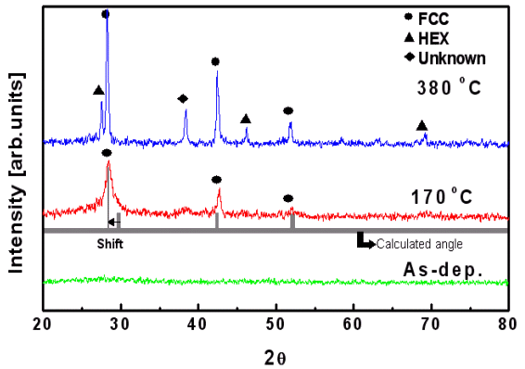
Figure 1 Caption (Times New Roman, 9 points, justified). Please use ‘text box’ for inserting figures. Large figures may extend over two columns.

The background section should be written from the standpoint of researchers without specialist knowledge in that area and must clearly state - and, if helpful, illustrate - the background to the research and its aims. The section should end with a very brief statement of what is being reported in the article. Please refer to references using square brackets [1-6]. Please use the reference format presented at the “Reference” session for this full paper. All figures and tables presented in the full paper must be numbered in the order that they appear in the text and must be referred to in the text. Within your text, Table and Figure must always be written out in full, for example Table 1 or Figure 1, using bold Times New Roman 10 points.

Table 1 Concentration characteristics Caption (Times New Roman, 9 points, justified).

Concentration  (wt.%) | Current  (mA) | Factor | Ratio (%)
0.000 | 5.95 | 0.73 | 3.33
0.025 | 8.45 | 0.84 | 5.67
0.050 | 6.40 | 0.74 | 3.73
0.075 | 6.69 | 0.67 | 3.43
0.100 | 6.14 | 0.46 | 1.63
1.000 | 2.50 | 0.39 | 0.35

Materials and Methods
This may be divided into subsections if several methods or techniques are described, as in the example below.
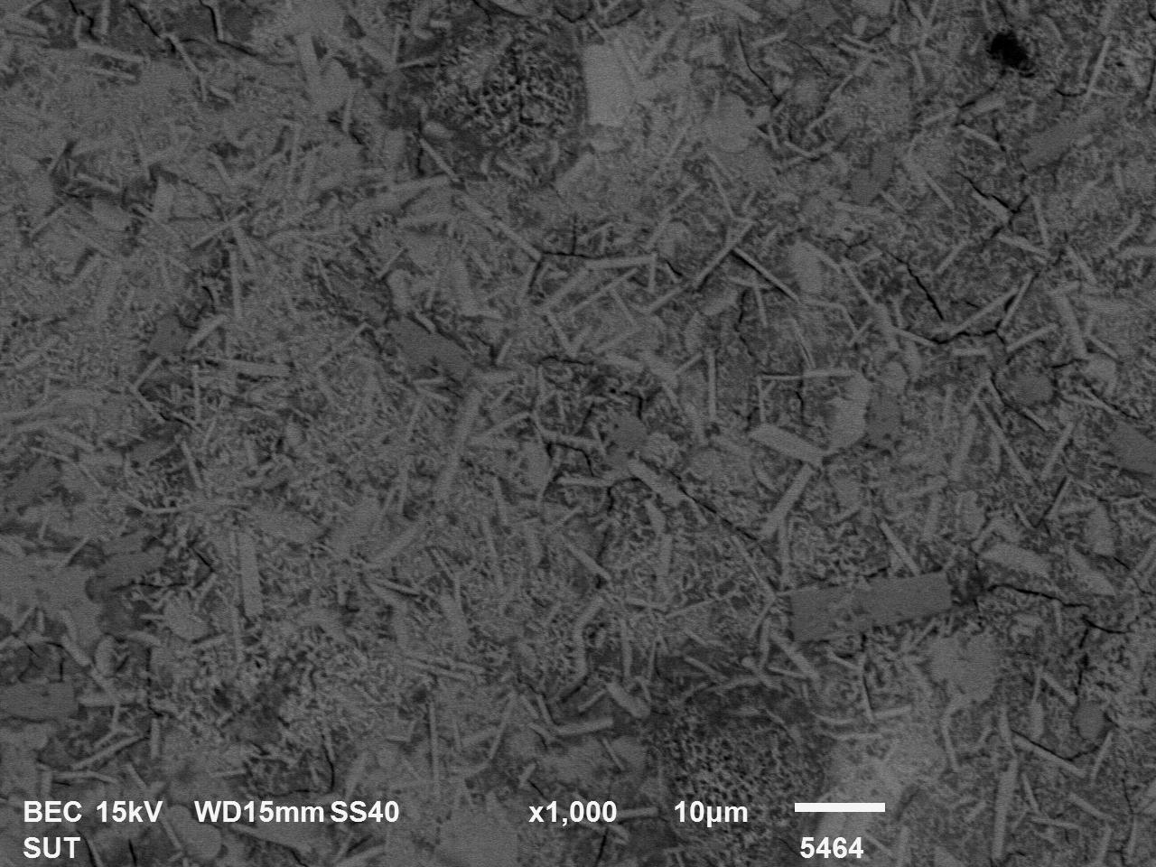

Figure 2 Caption (Times New Roman, 9 points, justified). Please use ‘text box’ for inserting figures. Figures may also be inserted into a single column.
Sample preparation (italic Times New Roman 10pt)
Details of the materials involved and experimental procedures should be sufficiently given.

Characterization (italic Time New Roman 10pt)
Methods already published elsewhere should be indicated by a reference. Only relevant modifications should be described.

Results and Discussion
The Results and Discussion may be combined into a single section or presented separately. They may also be broken into subsections with short informative headings, using Italic Times New Roman 10pt). Tables and Figures may be placed as a single column format (Figure 1) or a full width format (Figure 2). Please insert figures as one image inside the text box for each figure. This can be achieved using photo-editing software. Please avoid placing many image files into the text box. This may result in lost of images. Please ensure that all text labels are clear and legible.
Tables should also be inserted as a text box format (Table 1).

Conclusion
This should state clearly the main conclusions of the research and give a clear explanation of their importance and relevance. Summary illustrations may be included.

Acknowledgements
These should be kept to a minimum.

References
First Initial. Surname, Title, Journal abbreviation, Volume, pages (Year).
S. Shuman, Structure mechanism and evolution of the mRNA capping apparatus, Prog. Nucleic Acid Res. Mol. Biol., Vol. 66, 1-40 (2000).
First Initial. Surname, First Initial. Surname, Title, Journal abbreviation, Volume, pages (Year).
P. Chomczynski, N. Sacchi, Single-step method of RNA isolation by acid guanidinium thiocyanate-phenol-chloroform extraction, Anal. Biochem., Vol. 162, 156-159 (1987).
First Initial. Surname, Book Title, Edition, Publisher, City published, Page(s) (Year).
J. Sambrook, E.F. Fitsch, T. Maniatis, Molecular Cloning: A Laboratory Manual, 2nd Edition, Cold Spring Harbor Press, New York, 18-25 (1989).

